

FACULTY OF TECHNOLOGY AND ENGINEERING
DEVANG PATEL INSTITUTE OF ADVANCE TECHNOLOGY AND RESEARCH
DEPARTMENT OF INFORMATION TECHNOLOGY

A.Y. 2026-27 [ODD]

LAB MANUAL

CSUC201: DSA


Practical 1: Array Operations: Traversal, Rotation, and Frequency Analysis

Problem 1:
A bakery prepares n items every morning and places them in a display row. At the end of each hour, the leftmost item is moved to the rightmost position to make room for fresh stock at the front. Given the initial row and the number of hours h, print the final display order.
Describe the approach you used. How does it behave when h is very large, say 10 million? Is there a way to get the correct result without performing the operation h times?
Code:
https://github.com/krishangpatel16-dotcom/FDSA-Batch-B/tree/main/Practical%201

Problem Faced:
In this problem statement, I solved it using 2 ‘for’ loops but I wanted to solve it using 1 loop that difficulty I faced during this practical and solved it.

Output:
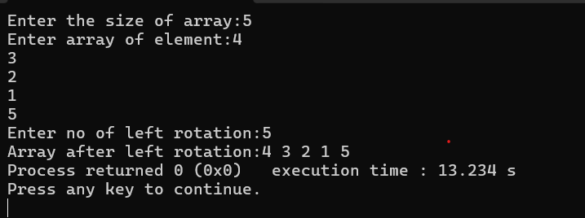

Key Question:
The display order repeats itself after a certain number of hours regardless of how large h gets. Without trying any specific example, explain why this repetition is inevitable and what determines when it first repeats.
The display repeats every n hours, where n is the number of items regardless of how large h is. This is why computing h % n before rotating gives the correct final order without simulating each hour individually.

Problem 2:
A library issues books to students and records each book's ID every time it is borrowed. At the end of the month, the librarian wants to find all books that were borrowed more than once, as those need priority restocking. Given the borrowing log, print all such book IDs.
Describe the approach you used. How many times does your solution scan the data? If the library had 100,000 borrow records, would your approach still be practical? Can you think of away that requires fewer passes?

Code:
https://github.com/krishangpatel16-dotcom/FDSA-Batch-B/tree/main/Practical%201

Problem Faced:
In this Problem statement, I checked every element from 0 to I and then I + 1 to n. I wanted to check all the elements at once that was difficult, I faced it during this practical and solved it.

Output:
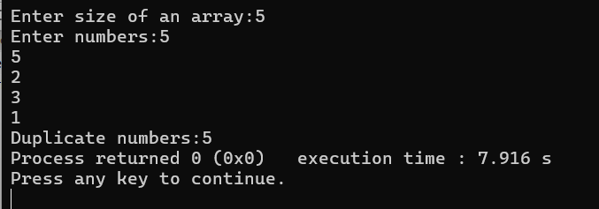

Key Question:
If the same book ID appears three times in the log, should it appear once or three times in your output? Does your solution handle this correctly, and how would you verify it?
Once. The output should list distinct book IDs that need restocking, not a count of how many times each was borrowed. Yes, both versions iterate over the count map's keys.so each qualifying book ID is added exactly once regardless of whether it was borrowed 2, 3, or 300 times.

Problem 3:
A school newspaper editor wants to highlight the most impressive word from a submitted article on the front page. The word is chosen simply by length — the longest one wins. Given a sentence, print the winning word and how many letters it has.
Describe the approach you used. What does your solution do when two words have the same length? Is that behaviour intentional, and can you think of a way to handle it explicitly?

Code:
https://github.com/krishangpatel16-dotcom/FDSA-Batch-B/tree/main/Practical%201

Problem Faced:
In this problem statement, I wanted to use two strings one of them is empty which stores the word which has the largest length. But I faced this problem to store the word that has longest word to another empty string.

Output:
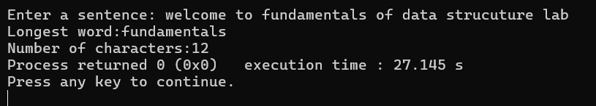

Key question:
The editor later decides that punctuation attached to a word (e.g. “hello,” or “great!”) should not count toward its length. How would this change your solution, and at which step would you handle it?
At the word-extraction step right after splitting the sentence into words, and before any length comparison happens. It's a one-time clean-up applied uniformly to every word. Doing it early means every downstream step automatically works with "clean" lengths you don't have to remember to strip punctuation every time you measure a word.

